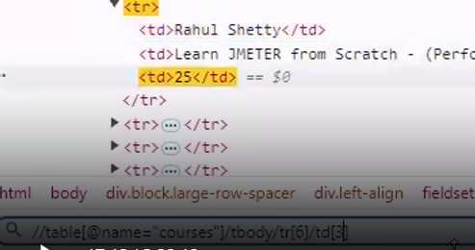

# Create the webtables .js file in the advanced folder

## Code:

///<reference types=”cypress” />

///<reference types=”cypress-xpath” / >

describe(‘webtable test’, () => {

it(‘test1’, () => { cy.visit(‘https://rahulshettyacademy.com/AutomationPractice/’);

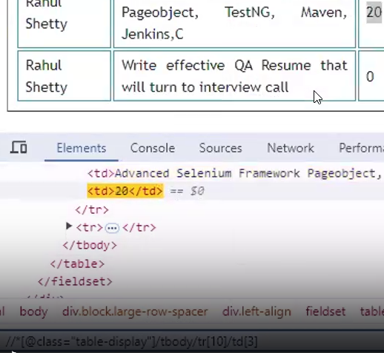

// To print the value 20

cy.xpath(‘//*[@class=”table-display”]/tbody/tr[10]/td[3]’).then(($ele) => {

// cy.log() is used to print in the console of cypress

cy.log($ele.text());

});

// Deal with multiple values in your webtable – iterate over them.

// Compare the text of a matching element, fetch the next element.

It(‘Multiple Element Test’, () => {

cy.visit(‘https://rahulshettyacademy.com/AutomationPractice/’);

// Iterating matching elements using each()

cy.xpath(‘//table[@class=”table-display”]/tbody/tr[8]/td’).each(($ele) => {

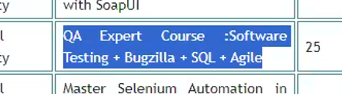

if($ele.text().includes(‘Bugzilla’)){

// next() will point out to the next element in the iteration

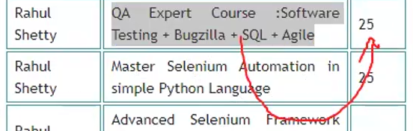

cy.wrap($ele).next().then((num) => {

cy.log(num.text())

})

}

})

});

});

});

# Create tabs1.js file in advanced folder

///<reference types=”cypress” />

///<reference types=”cypress-xpath” />

describe(‘tabs test 1’, () => {

it(‘test1’, () => {

cy.visit(‘https://rahulshettyacademy.com/AutomationPractice’)

// Removing an attribute in cypress using invoke()

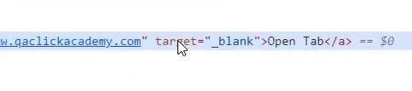

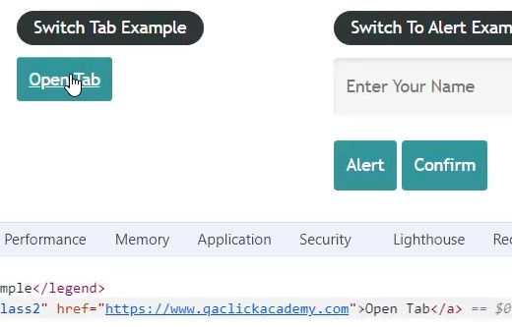

// cy.xpath(“//a[@id=’opentab’]”).click();

// we want the link to be open in the same tab

cy.xpath(“//a[@id=’opentab’]”).invoke(‘removeAttr’, ‘target’).click();

// To work on different link / origin we have to use cy.origin()

// then only we can interact with the origin

cy.origin(‘https://www.qaclickacademy.com/’, () => {

cy.contains(‘Courses’).click();

// log the current url

cy.log(cy.url())

})

cy.log(cy.url()) #https://students.masaischool.com/lectures/86850?tab=notes

})

});